**Ex.no.7 Date :**

**CASE STUDY: POINT -OF -SALE TERMINAL**

**a)Aim:** Develop High-Level Sequence Diagram for each usecase.



**b)Aim: Identify MVC Classes**

**View Model Controller**

ICashier Sale Saleslineitem

ICustomer Store Product Specification

IManager Payment Item

IProductCatalog Post

**c)Aim:** Develop Communication Diagram



d)**Aim:** GRASP Patterns and their Responsibilities

**creates**

Saleslineitem

Sale

Sale Creates Saleslineitem and also responsibility assigned for Saleslineitem i.e., creator, information expert patterns.

Contains

Product Specification

Product Catalogue

Product Catalogue Contains Product Specification and also responsibility assigned for Product Specification i.e., low coupling, information expert patterns.

Item

Store

Stocks

Store specify stock of an item and also responsibility assigned for items i.e., Controller, information expert patterns.

Add payment paid by

Customer

Payment

Cashier

Cashier add payment and customer paid by that particular payment and also responsibility assigned for payment i.e., High Cohesion, information expert patterns.

post

Manager

**started by**

Manager started by post and also responsibility assigned for Manager i.e., Controller, information expert patterns.

e) Aim: Developing three layered package diagram for point of sale

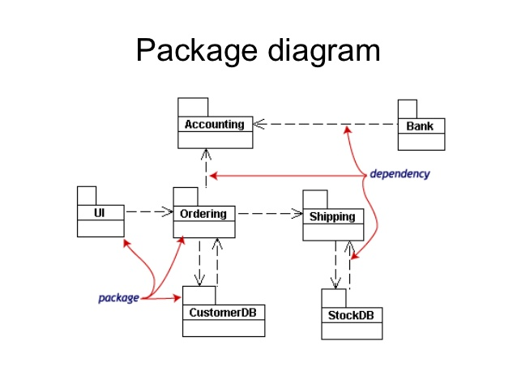

**Result:** The Design was successfully completed.